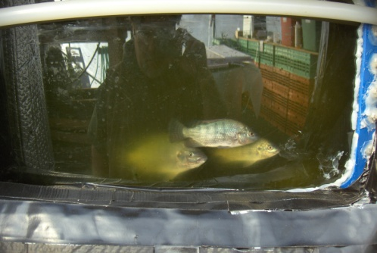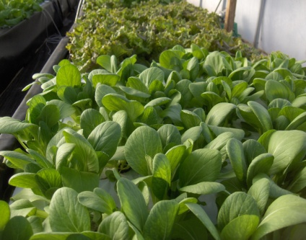
Introduction to Aquaponic Growing System Class and Workshop!
What: An introduction to the basic concepts of home or small commercial aquaponics. This is a system in which Aquaculture (raising fish) is combined with Hydroponics (soilless plant growing) with a recirculation of water to grow fish and plants using the same resources. Students will be introduced to a commercial system developed by the University of the Virgin Islands and a home size model based on The Growing Power system. Students will help build a working model during the afternoon portion of the class.
When: Saturday 27 March 2010 – 9:00 – 4:00 (bring lunch – liquid refreshments provided)
Where: Regional Food Bank of Oklahoma 3355 S Purdue, Oklahoma City, Oklahoma 73137
Cost: $25.00 per student (Maximum Class 25 students)
Register/Information: Contact Bruce Edwards 405-604-7108 or email bedwards@regionalfoodbank.org
