Come see the
OK Coal Cycle
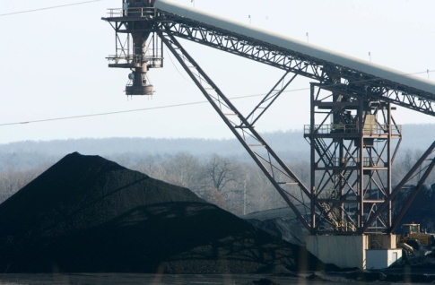
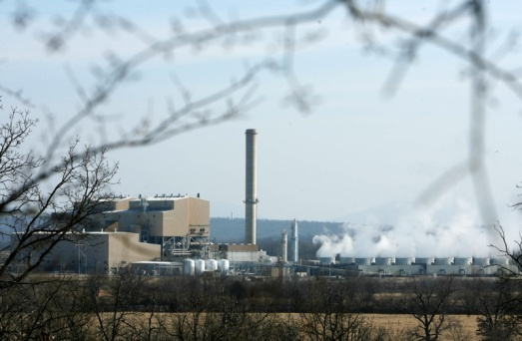
Sierra Club
Fly Ash Trip
Sat. April 17,
2010

Coal pile at AES Shady Point AES Shady Point
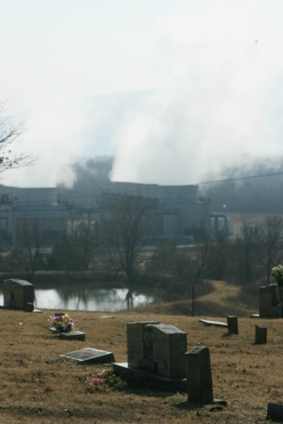
8:00 a.m. | Depart from Java Dave’s, Oklahoma City and Tulsa (t/b/a) In route we will discuss efforts in Bokoshe
9:30 – 9:45 | Meet in Henryetta for Travel Break
11:30 --12:30 | View Coal Burning Power Plant and Fly Ash Pit
12:30 –2:00 | 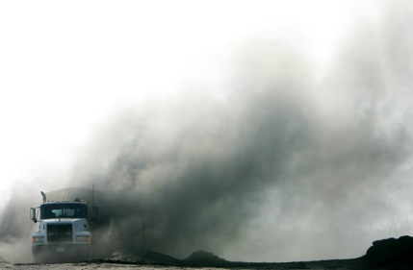  Box lunch and Presentation on Bokoshe History
2:00 -- 3:00 | On site visit to land onto which water is discharged.
3:00 | Depart from Bokoshe
6:00 p.m.  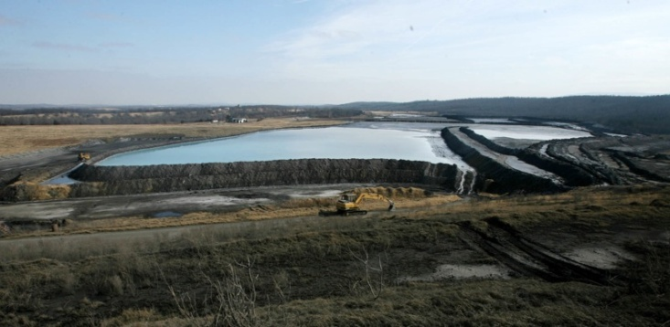 | Arrive OKC and Tulsa  Dumping Flyash in Bokoshe
 | Making Money Having Fun
Making M
Tell everyone what you saw in Bokoshe, Oklahoma

Bokoshe Fly Ash Issues, Questions and Answers
Issue No 1. Oklahoma Department of Mines (ODM) is permitting MMHF, LLC to build a mountain of fly ash. They call it a mine reclamation project. On this trip you will see it is not a reclamation project. Why does ODM let this continue?

Issue No. 2. Oklahoma Corporation Commission, (OCC) permits MMHF to dump saltwater from oil and gas wells on the fly ash. OCC’s regulations and MMHF’s permit say a saltwater pit cannot be within 3 miles of an incorporated town. On this trip you will see the pit is less than 2 miles from Bokoshe. Why does OCC let this continue?
Issue No. 3. For at least a year ODM and ODEQ took no action to stop MMHF from releasing polluted water into surrounding streams. EPA ordered MMHF to stop the pollution. You will see the pollution continues. Why do ODM, ODEQ and EPA let this continue?
Issue No. 4. For 7 years ODEQ did not enforce the law that requires MMHF to control fly ash dust. ODEQ will not investigate health impacts of these 7 years of violations. On this trip you will learn of the respiratory problems and cancer in Bokoshe. Why doesn’t ODEQ study the health impacts?
Answer: A polluter with money is more powerful than a citizen who votes. This is true until people who have seen the injustice with their own eyes demand that the injustice stop. You can make that demand at a public meeting, in an e-mail, by telephone or a letter. Describe the injustice, tell the person that they have the power to stop it, and ask for their help. These are a few of the people who can help.
Go tell what you saw in Bokoshe
Secretary of the Environment  J.D. Strong (405) 530-8995  Director of Policy and Communications Amanda Storck, (405) 530-8995  3800 North Classen Boulevard  Oklahoma City, OK 73118 | Director Oklahoma Department of Mines  Mary Ann Pritchard (405) 427-3859  Doug Schooley (405) 427-3859  Bret Sholar, (405) 427-3859  2915 N. Classen Blvd., Suite 213  Oklahoma City, OK 73106-5406
Steven Thompson, (405) 702-1000  Oklahoma DEQ Executive Director  Eddie Terrill, Eddie.Terrill@deq.ok.gov  Air Quality Division Director  P.O. Box 1677  Oklahoma City, OK 73101-1677 | Senator Kenneth Corn  2300 N. Lincoln Blvd., Rm. 531  Oklahoma City, OK 73105  (405) 521-5576  cochran@oksenate.gov  Executive Assistant: Susan Cochran

For more information contact RoseMary Crawford (405) 206-3979

