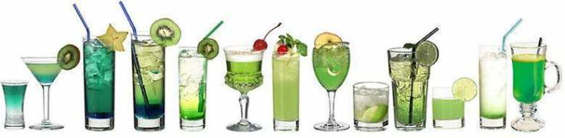

Join Sustainable OKC for our December Green Drinks and Christmas Party!

When: Tuesday, December 13th at six o’ clock in the evening

Where: Bosa Nova Bar on the second floor of Café do Brazil 440 NW 11th St Ste 100, Oklahoma City, OK

Bring a friend. Bring a neighbor. Bring an opinion.



The fine print: Green Drinks in Oklahoma City is hosted by Sustainable OKC and is an opportunity to meet for friendly, lively conversation and drinks with all sorts of people. Informal and unstructured, Green Drinks provides opportunities to make new friends and catch up with old ones, develop ideas, argue strategies, find employment, and network with others. Email Leslie Steyer at lesliesteyer@gmail.com if you have any questions.

