Sustainable OKC
&
The U.S. Green Building Council - Oklahoma Chapter
Invite you to the
Green Drinks Spring Social
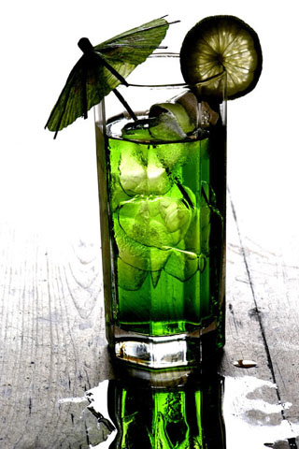
When: Thursday, May 31st 5pm - 8pm
Where: Bellini’s Ristorante Bar
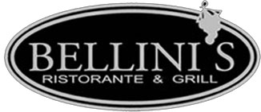
6305 Waterford Blvd. #100 Oklahoma City 73118 (405) 848-1065

Join Sustainable OKC and the USGBC – Oklahoma Chapter to network with like-minded folks and learn more about each organization and their sustainability efforts.
This is the time to show your support by joining SOKC and/or USGBC-OK.
Email Leslie Steyer at lesliesteyer@gmail.com if you have any questions.
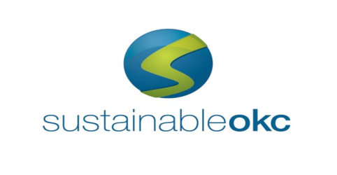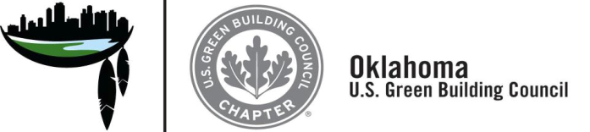
www.SustainableOkc.org www.usgbc-oklahoma.org
Show your pride in our state by volunteering and becoming a member.

